Jr. Shodan Proposal
David Matsumoto
Daiheigen
The Need
The number of individuals in the USJF being promoted to shodan has been reducing, sometimes drastically, over the past number of years (Figure 1).
Figure 1
Raw Number of Shodan Promotions by Year
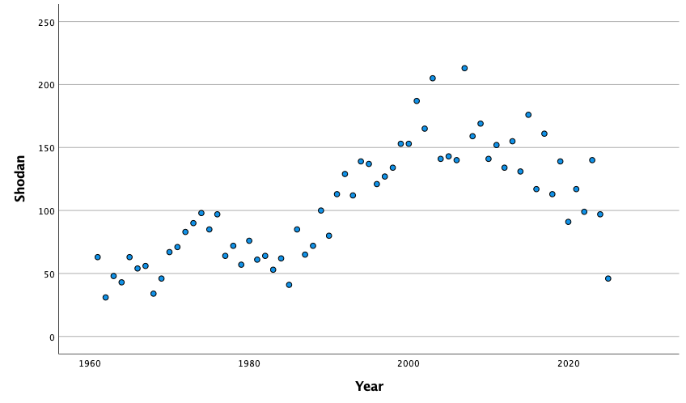
Some may say that such a decline is natural because registrations have been down, but the same declines in trends in shodan promotions exist even when expressed as a percentage to the total number of promotions (Figure 2) or as a percentage to the total registration in the USJF (Figure 3). Figures 2 and 3 in particular demonstrate that the USJF is promoting substantially less shodans than compared in the past and when compared to other promotions or to USJF registration.
Figure 2
Percentage of Shodan Promotions to All Promotions by Year
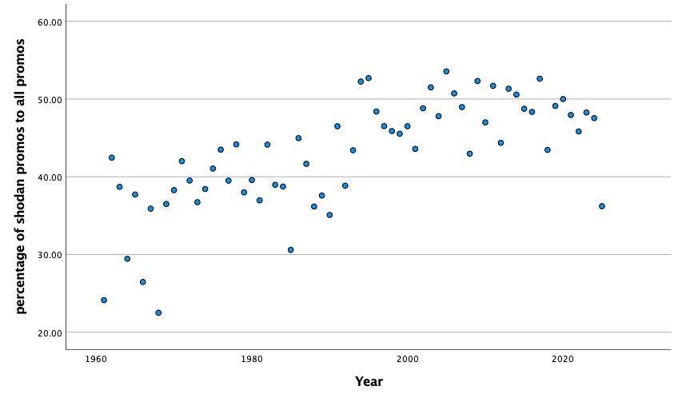
Figure 3
Percentage of Shodan Promotions to Total Registrations by Year
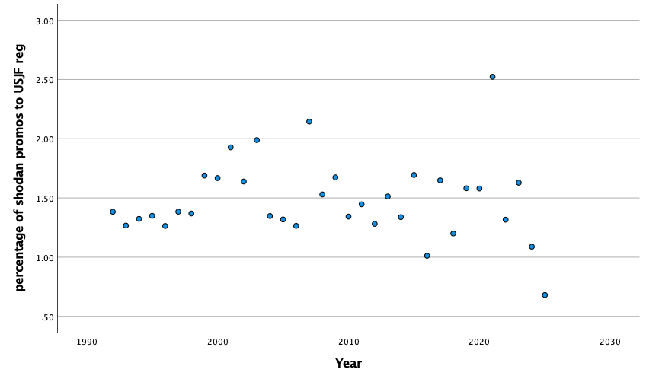
A Potential Contributor to the Decline
One potential contributor to the decline in the number of shodan promotions may be that the requirements are perceived as too cumbersome and overwhelming. Eligible applicants are expected to spend a long time (two years for non-competitors) AND have competency as an Assistant Teacher, suggested Teachers or Coaches Certification, know and be able to demonstrate many techniques that may be considered esoteric and/or irrelevant to judo practice and competition until then, be able to do all five sets of Nage-no-Kata as both tori and uke, and have experience as a referee, tournament official, or teacher (for non-competitors).
Proposed Solution
The original intent of the rank of shodan in Kodokan judo was as implied by its characters: a beginning rank (初, beginning or start, and 段, level). The current requirements for juniors have gone far from this original intent. The proposed solution is suggested to reduce the burdensome and overwhelming requirements to make it easier for USJF instructors to promote their students to shodan.
Recommendation:
- Minimal Age: 14
- Minimal Time in Grade as Ikkyu
  - Non-competitor - 1 year
  - Competitor
    - 5 points – 6 months
    - 10 points - 3 months
    - Batsugun – immediate
  - All time in grade requirements should reflect regular, continuous, weekly practice greater than or equal to two times per week
    - i.e., one year = 52 weeks, and thus one year time in grade should correspond to at least 104 (52 weeks x 2 times per week) judo practices
- General Requirements:
  - Good moral character and maturity.
- Kata requirements
  - Non-Competitors
    - First three sets of Nage-no-Kata, tori only
  - Competitors
    - See suggested amended kata requirement
- Additional requirements for non-competitors

Amended Jr. Shodan Kata Requirements
A separate obstacle to fewer shodan promotions may also be the way in which kata is practiced for promotions. I believe that kata is perceived as the nuisance thing that people need to do in order to get promoted. Thus, most individuals will cram the required kata practice prior to a promotional event to get promoted. Moreover, the techniques in the traditional Kodokan Nage-no-Kata are often perceived as outdated, out-of-touch, and lack practical application, which adds to negative perceptions concerning it. Uki Otoshi, kata guruma (standing), uki goshi, and tsurikomi goshi are all rarely seen in contemporary judo practice or competition.
Amended Kata Recommendation: To amend the USJF kata promotion requirements for shodan to be as follows:
- Instructors and students have the choice to do the original Kodokan Nage-no-Kata, or to do a modified version of nage-no-kata along the following specifications:
  - Bowing and entry/exit formalities to be the same as the original Kodokan Nage-no-Kata
  - Techniques to be demonstrated include three techniques from each of the following three sets (total nine techniques to demonstrate):
    - Te-waza
    - Koshi-waza
    - Ashi-waza
  - Each technique to be determined by the instructor and student as relevant to the student’s repertoire. Thus, each student can perform different sets of techniques that are unique and customized to that student.
  - Each technique to demonstrate the principles of kuzushi, tsukuri, kake, nage, and kime as in the original Kodokan Nage-no-Kata.
  - Each technique to be demonstrated on one side only, to be determined by the instructor and student. Performance sides can alternate across techniques as determined by the instructor and student.
Rationale
- By allowing instructors and students to select techniques relevant to each student’s repertoire, the kata will be more relevant to the student and not foreign.
- Allowing instructors and students to select techniques also allows for creativity for the creation of new versions of kata
- The requirement for each technique to demonstrate the principles of kuzushi, tsukuri, kake, nage, and kime as in the original Kodokan Nage-no-Kata maintain the original intent of the kata.
Hopefully amending the kata requirement for shodan promotions can facilitate promotions to this beginning rank.

