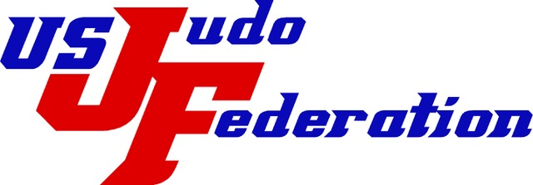
United States Judo Federation
National Promotional Committee
Meeting Agenda for April 25, 2025
Miami, FL
- Opening - Call to Order
- Establish Quorum (See below for attendance at meeting)
- Moment of Silence for those that have passed
- Adoption of Agenda - motion _________, second ________
- Review minutes of meeting on November 2024 motion _______, second ________
- Review minutes of meeting on March 2025 motion _________, second ________
- Promotional Candidate Review –
  - Peter Iglesia – Florida YDK – Sandan to Yodan
  - Omar Madan - Florida YDK – Sandan to Yodan
  - Benito Ramos - – Florida YDK – Sandan to Yodan
  - Drue Ferguson – Makoto YDK – Sandan to Yodan
  - William Gugino – Niagara YDK – Sandan to Yodan
  - Andre Boulet – Niagara YDK – Yodan to Godan
  - Sherwin Hiraoka- Hawaii State YDK - Godan to Rokudan
  - James Murray -Konan YDK - Godan to Rokudan
  - Calvin Terada – Northwest YDK – Godan to Rokudan
  - Robert Winston – Shufu YDK – Godan to Rokudan
  - Warren Shimizu – 50th State YDK – Rokudan to Shichidan
  - John Schaedler – Northwest YDK – Rokudan to Shichidan
  - Alvin Terada – Northwest YDK – Rokudan to Shichidan
  - Clark Edison – Rokushu YDK – Rokudan to Shichidan
- Old Business -
  - Changes/tweeks to current form 20
  - Competitor Classification adjustment and tweeks to BOE
  - High dan promotion guidelines
  - High dan promotion form development
  - Dan form 20 and paperwork submissions
  - Competitor class for life discussion/revisit
  - PC Committee handbook
  - Mentoring for younger PC members
  - Mentoring volunteers for small YDK
- New Business
  - Discussion on Presidential Promotion authority
- Date of next promotional – tentative plan for November ?? 2025 , location: Las Vegas, NV
- Closing

