
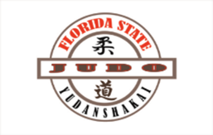
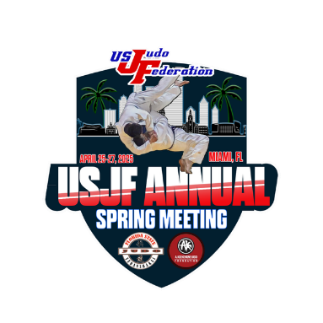
AREAS OF INTEREST TO SEE IN MIAMI

- DADELAND MALL, VERY EXCLUSIVE SHOPPING MALL – NEXT TO THE AC HDQ HOTEL

- TOWN AND COUNTRY MALL - THE PALM – SHOPPING MALL – 117TH AND KENDALL DR

- THE FALLS – SHOPPING - RESTAURANTS

- SUNSET PLACE – SHOPPING MALL AND RESTAURANTS

- CALLE OCHO – LITTLE HAVANA – BARS, RESTAURANTS, CIGARS

- VERSAILLES RESTAURANT – CUBAN TYPICAL FOOD RESTAURANT

- LITTLE HAITI- NORTHWEST MIAMI

- MIAMI ZOO – SOUTH KENDALL

- HOMESTEAD RACE TRACKS - HOMESTEAD

- EVERGLADES- MICOOSUKEE RESERVATIONS, ALLIGATORS BOAT RIDES

- COCONUT GROVE AREA – COCOWALK CENTER – RESTAURANTS

- REGATTA GROVE – COCONUT GROVE

- VILLAGE OF MERRICK PARK – CORAL GABLES

- MIRACLE MILES – CORAL GABLES

- BRICKELL CITY CENTER – BRICKELL AVENUE

- BAYSIDE – SHOPPING RESTAURANTS – DOWNTOWN MIAMI

- DOWNTOWN MIAMI - MIAMI HEAT BASKETBALL STADIUM – MIAMI MARLINS STADIUM

- WYNWOOD WALLS – RESTAURANTS – COYO TACO - KITCHEN BAR

- MIAMI BEACH - SOUTH BEACH – RESTAURANTS – DANCING - OCEAN DRIVE- BEACHES

- MIAMI DOLPHINS STADIUM – MIAMI GARDENS

